TSC Surgeries:

For every surgery, in these instruments: forceps, Wescott’s, needle driver, bipolar forceps
On every tray: CTAs, gauze, emycin on indicator strip, 3 cc syringe, 30g needle, drape (1 per each eye)
Surgeries always use 15 blades
Put emycin on all gut sutures
Always goes around needle driver 3 times when tying a suture
Cut both ends for interrupted, cut one end for running
Pretty good videos about everything, best videos we have found: Oculoplastic Surgery Techniques (eyerounds.org)

Ectropion/Entropion repair: LTS (most the time)
- LTS- Lateral Tarsal Strip

- https://eyerounds.org/video/plastics/1/Medial-spindle-lateral-tarsal-strip-repair-ectropion.htm (?)

- https://eyerounds.org/video/plastics/1/lateral-tarsal-strip.htm
- Instruments- forceps, Wescott’s, needle driver, bipolar forceps
- Suture- 5-0 Fast gut, mersilene
  - Load mersilene first
- What used first- forceps and wescotts
- Usually does interrupted to close

- Wescotts forceps to make initial cut
- Cautery, regain hemostasis
- Probably wescotts and forceps again to adjust incision
- CTAs to control bleeding, also sometimes uses CTA and wescotts to get down to bone
- Uses Mersilene to lift eyelid
- Cut one needle of mersilene, he will then tie the suture, and cut the other needle off
- Close with gut, most likely interrupted gut sutures

Upper blepharoplasty: BULB

- BULB- bilateral upper lid blepharoplasty
- https://eyerounds.org/video/plastics/1/Upper-lid-bleph-w-monopolar-cautery.htm
- Instruments- forceps, Wescott’s, needle driver, bipolar forceps, blade handle, 15 blade
- Suture- 5-0 Fast gut ***If cosmetic, use 6-0 prolene
- What used first- 15 blade
- Usually does running suture to close

- Will use 15 blade to cut outline, give gauze
- Uses wescotts and forceps to cut off skin
- Cautery, give gauze and use CTA for small bleeds
- Look for imperfections, may use wescotts and forceps again
- Cautery again if needed
- Close using suture and forceps, wescotts to cut ends

** IF doing a BULB revision, will also need hot temp

External levator resection: ELR

- https://eyerounds.org/video/plastics/1/External-levator-advancement.htm
- Instruments- Instruments- forceps x 2, Wescott’s, needle driver, bipolar forceps, blade handle, 15 blade, hot temp
- Suture- 5-0 Fast gut, 6-0 nylon x 2
- Usually does interrupted sutures

- Will use blade to open line, give gauze
- Cautery
- Will probably use the hot temp and forceps to dissect down to muscle
- Cautery
- Once where can see everything, will use nylon and forceps
- Will either tie suture completely, or will do a half tie and have pt open eyelid to see how much lift he is getting
- Will place second nylon
- Will have pt open eye a few times to make sure lift is good
- Will tie nylons
- Will close with gut and forceps, interrupted

Internal levator resection: ILR

- Or called MMCR- same thing
- https://eyerounds.org/video/plastics/1/muller-muscle-conj-resect-1.htm
- Instruments- 2 forceps, wescotts, needle driver, bipolar, 15 blade (1 per each eye), blade handle, putterman clamp, Desmarres, calipers, surgical marker
- Sutures- silk, double arm 6-0 gut (1 per each eye)
- Will probably not use bipolar
- Don’t need a monopolar in the surgery center

- Give silk suture, he will stitch through upper lid edge and will use suture tails to manipulate lid
- Give desmarres, he will flip lid
- Give local, he will inject underside of upper lid with local and then squeeze/dry it with gauze
- Give calipers inked and marked on specific number. He will make marks on inside of upper lid.
- Give him one forcep, place putterman clamp on patient’s chest on drape, and grab other forcep and CTA
- TSC will grasp piece of tissue on lid and have you grasp it, then he will grasp other tissue on lid, and you will use CTA to push down on upper lid, creating a sheet of tissue that tents up
- TSC will use clamp to grasp sheet of tissue, do NOT let go of forceps/CTA until instructed to do so
- He will then use double-armed 6-0 gut suture (do not cut it) to suture lid underneath where it is clamped
- Once both suture tails are on the same side toward surgeon, he will grab 15 blade on blade handle and you will use CTA to hold suture tails and lid tissue down and away from the blade.
- Once he cuts clamped tissue, he will check that the suture did not break and will use needle driver and forceps to finish tying off sutures and will use westcotts to cut them.
- If doing bilateral, make sure to unclamp putterman clamp and clean off muscle tissue and swap 15 blade off blade handle for a new one

Lower blepharoplasty: BLLB

- Most of the time in surgery center
- https://eyerounds.org/video/plastics/1/transconj-LL-bleph-w-fat-resection.htm
- Will probably use laser
- Instruments- Instruments- forceps x 2, Wescott’s, needle driver, bipolar forceps, Desmarres, laser handle,
- Sutures: 4-0 Silk,5-0 Fast absorbing Gut

- TSC will separate conj from rest of lower lid
- Will use silk and a hemostat to hold conj up
- Will continue to dissect down until exposing all the fat pads, will use desmarres during this to hold skin up and will often need CTAs
- The LLs can have some big veins and such, be ready with CTAs to use as needed
- You move the desmarres with him (medial, central, lateral) so that he may get all the fat. He will likely use adsons forceps as they are bigger and can grab the fat easier. He will then use the laser to cut out the fat, using the desmarres as the surface to laser on
- You must keep track of where the fat is coming from (medial, central, lateral), and keep the piles separate. So, you should have three piles of fat for each eye
- He will do the other eye same way, then go back and check them both making sure a even amount was take out of both. You simply follow him, hold the desmarres, and help cta any bleeding
- Once satisfied with both sides, he will close the conj with 5-0 fast gut, usually two interrupted sutures. He will cut these sutures himself

Mohs Reconstruction Surgery

- Pt’s come in after having a mohs procedure done at a different clinic (removal of skin cancer). We then essentially have to close the hole that the other clinic left in the skin. They will come in with a patch on usually
- These surgeries are always different, as you never know exactly what you will get until you see the pt
- Most of the time in the surg center
- All the normal instruments, maybe others but just as needed case by case, maybe a 15 blade
- Sutures: Unkown, but normally need a couple vicryls, 5-0 fast, maybe silk to do a frost suture

There are no exact steps to this one since they are always different, but normally go about like this
- Will usually start by making a longer incision, this way the we are freeing up skin/making it more moveable. You will CTA PRN.
- TSC may dissect down a bit to again make skin more moveable, just maintain homeostasis
- Once he has enough skin to cover the defect, will then suture, starting with deepest sutures first (vicryl). He mainly cuts the deep sutures himself.
- Pass sutures and mainatain homeostasis
- Close with the gut
Sometimes the defects are very large and require skin grafts. Skin grafts can come from a few different places, including behind the ear, the inside of the other eye, and the upper eyelid of the affected eye
Skin grafts need to be closed like normal wounds, except the inside of the other eyelid, that is simply left open as it will heal on its own.
If get skin graft, most important thing is not to lose it. He will give it to you, you must put it in a secure spot on your tray. Depending on how long until we will use it also, he may ask you to wrap it in wet gauze. Ask what to wet the gauze with
Wedge Resection

Pretty much the same thing as the mohs, except we remove the cancer also. All this means is that we cut out a part of the eyelid then do all the steps of the mohs to put it back together again. Same everything else.
https://eyerounds.org/video/plastics/1/Full-Section-Wedge-Resect-Repair.htm

Sling Procedure

- Very similar to ELRs
- https://eyerounds.org/video/plastics/1/Bilateral-Silicone-Frontalis-Suspension.htm
- Will need one sling per eye. Slings can be silicone or the Ruben ones, just ask TSC which one
- Instruments- Same as ELR, Basic set up, maybe will need two prong, maybe
- Sutures: 6-0 Nylon and 5-0 Fast

- Will use monopolar to open line, give gauze
- Cautery
- Will probably use monopolar and forceps to dissect down to muscle
- Cautery
- Once where can see everything, will use nylon and forceps and sling
- Will suture middle of sling into place
- Will then use needles on sling to push sling through to above the eye brow
- Will cut needles off sling
- Will tie sling temporary
- Will have pt open eye a few times to make sure lift is good
- Will tie sling together permanently, cut excess, and will tuck into would above brow
- Will close brow with gut and forceps, interrupted
- Close eyelids with gut

DCR

- External dacryocystorhinostomy (uiowa.edu)
- New surgeries in the surgery center
- Sutures: 6-0 Prolene (? Might be 5-0), 5-0 Vicryl, 5-0 fast
- Instruments- Complete normal set, specifically suction tip, freer, hemostat, punctal dilator, adsons, needle driver, wescotts, forceps
  - Will also need DCR sets/peel packs
    - Only the biggest bone hole puncher thing should be peel packed now?
- Extras you will need- gel foam, kenalog, Crawford stent, suction tubing
- Will have an extra mayo stand, can grab from clinic side
  - On this you will have nasal speculum, cup with afrin in it, bayonet forceps, and packing strips
- Make sure TSC can reach everything on table, he will pretty much have to do this surgery himself as you will have to hold the four prong rakes the entire time
- When he asks for packing strips, give it to him loaded on the bayonet forceps
- He will first pack the nose once he gets into the OR using all the stuff on the extra tray
- This surgery is not sterile technically, you will touch stuff off that extra tray after he has touched it, it is ok
- This is all subject to change, this is a new surgery for us, still learning

- A marking is made on the side of the nose half way between the bridge of the nose and the medial canthus
- An incision is made along the marking using monopolar
- He will dissect down until makes a good sized hole
- Will ask for four prong rakes, which you will pretty much just hold for the rest of the surgery
- The Freer periosteal elevator is then used to elevate the periosteum from the bone to the level of the anterior lacrimal crest. He does a bunch of stuff in the hole, you cannot really see all this. It bleeds a lot, so you need to have the suction tip and suction going
- Rogeurs of increasing size are then used to remove bone of the lacrimal sac fossa.
- The nasal mucosa is infiltrated with lidocaine with epinephrine.
- A number 66 Beaver blade is then used to make an incision, he does something
- The Crawford stents are then placed through the system
  - Maybe retrieved from the nose with a Crawford hook.
- Use grooved director to help place the stent
- Place a prolene suture around the stents at the level of the ostium to prevent post-operative stent prolapse.
- The incision is then closed with deep interrupted 5-0 vicryl sutures.
- The skin is then closed with interrupted 5-0 fast absorbing suture.
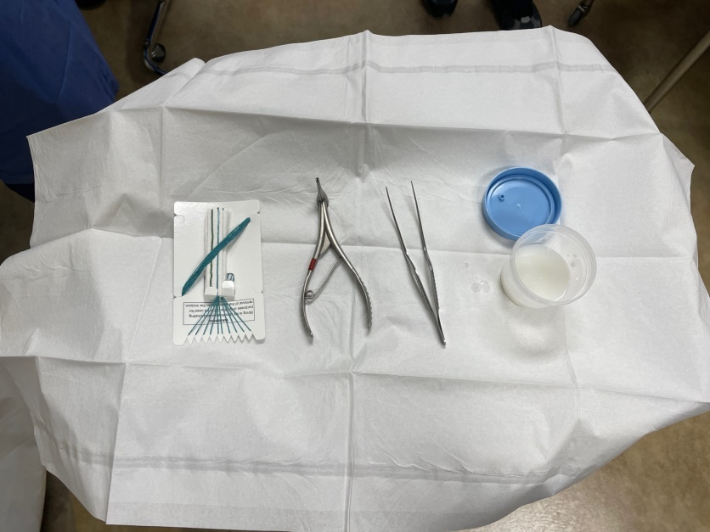 Extra Mayo Stand
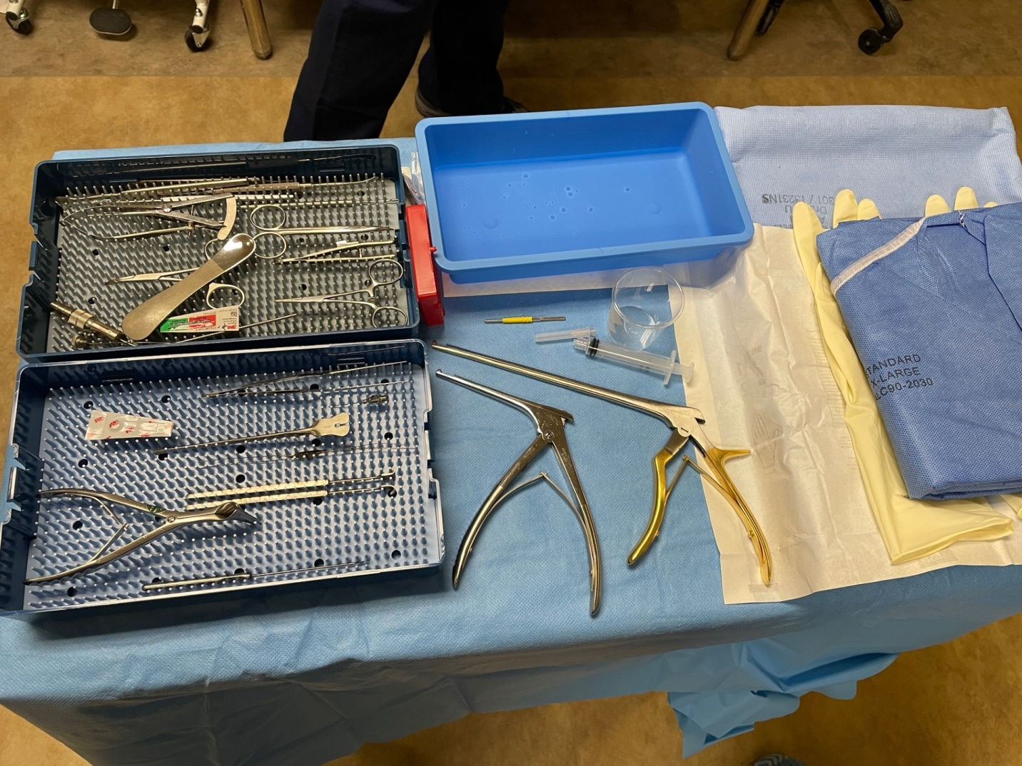
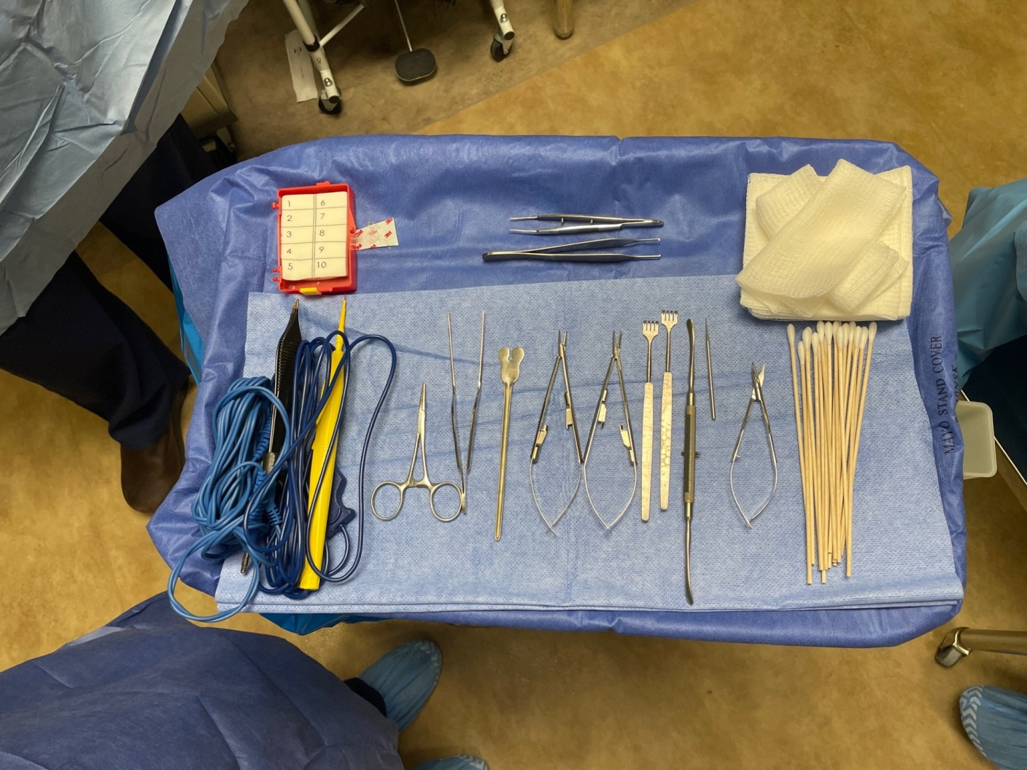

CO2 Resurfacing

- Will need the resurfacing hand piece, attach and adjust the weight to the 2nd red line
- Have the buffalo filter ready to go
- All you have to do is follow him around as he does the resurfacing, sucking up the stuff that comes up with the buffalo filter. Stay about an inch away, make sure to stay out of his way.
- Pt gets aquaphor everywhere where resurfacing was

Eyelid Retraction

- Super simple
- Sutures- probably only 5-0 fast
- Instruments- normal tray

Like an ELR, he dissects down, loosens all the tissue to lower the eyelid, then he simply sutures the eyelid closed. All the same basic steps
Sometimes he will use a two prong and put it under the eyelid to pull the eyelid down.
I cannot remember what else we even do for these
Gold weight

- Like ELR again
- https://eyerounds.org/video/plastics/2/Gold-weight-insertion.htm
- Sutures- 6-0 nylon and 5-0 fast (I believe)
- Instruments- normal tray

- Like an ELR, he dissects down, you do cautery while he does.
- You will hand him the gold weight and he will position it
- He will suture it in place with the nylons
- Then you pretty much just close the eyelid
Orbital mass excision
- Excision of lipodermoid (dermolipoma) (eyerounds.org)
- All you do is cut it out and leave it. We don’t even suture these closed most of the time

Endurgen graft
- https://eyerounds.org/video/plastics/13/101-Placement-enduragen-graft-pillar-tarsorrhaphy.htm

Brow pexy/minibrow lift

Temporal brow lift
- Temporal scalp incision browplasty on Vimeo

